AP21110010931

CSE - O

**RAILWAY MANAGEMENT SYSTEM**

**Aim:**

The aim of the Railway Management System is to efficiently manage and organize railway operations, including information about trains, passengers, reservations, ticketing, and other relevant data.

**Description:**

The Railway Management System typically includes the following components:

**Train Information**: Stores information about the trains, such as train name, departure and arrival stations, schedule, and seat availability.

**Passenger Information**: Contains details about passengers, including name, contact information, and ID.

**Reservation Management:** Manages passenger reservations, including reservation ID, passenger ID, train ID, and seat information.

**Ticketing and Payment**: Tracks ticket information, including the reservation, fare, and payment details.

**Station Information:** Stores information about railway stations, their names, and location details.

**Employee Information:** Manages information about railway staff, such as station managers and ticketing agents.

**Tables Required with Description:**

**Train Table:**

Train_ID (Primary Key)

Train_Name

Departure_Station

Arrival_Station

Departure_Time

Arrival_Time

Total_Seats

Available_Seats

**Passenger Table:**

Passenger_ID (Primary Key)

Name

Contact_Number

Address

**Reservation Table:**

Reservation_ID (Primary Key)

Passenger_ID (Foreign Key)

Train_ID (Foreign Key)

Seat_Number

Date

**Ticket Table:**

Ticket_ID (Primary Key)

Reservation_ID (Foreign Key)

Fare

Payment_Status

**Station Table:**

Station_ID (Primary Key)

Station_Name

Location

**Employee Table:**

Employee_ID (Primary Key)

Name

Position

Contact_Number

**E.R Diagram:**

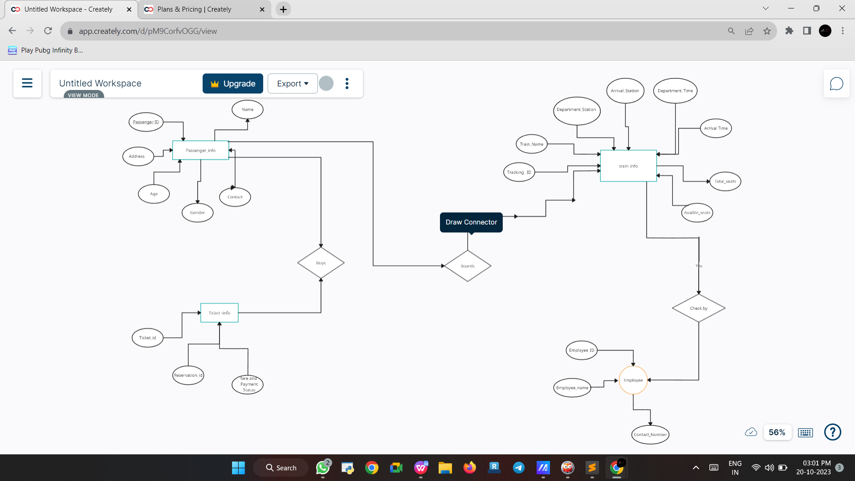

**Relational_Schema:**

**Train Table:**

**Train_ID (Primary Key)**: A unique identifier for each train.

**Train_Name:** The name of the train.

**Departure_Station**: The station where the train starts its journey.

**Arrival_Station:** The station where the train ends its journey.

**Departure_Time:** The time when the train departs from the departure station.

**Arrival_Time:** The time when the train arrives at the arrival station.

**Total_Seats:** The total number of seats on the train.

**Available_Seats:** The number of seats that are currently available on the train.

**Passenger Table:**

**Passenger_ID (Primary Key):** A unique identifier for each passenger.

**Name:** The name of the passenger.

**Contact_Number:** The contact number of the passenger.

**Address:** The address of the passenger.

**Reservation Table:**

**Reservation_ID (Primary Key):** A unique identifier for each reservation.

**Passenger_ID (Foreign Key):** Links to the Passenger table to associate reservations with passengers.

**Train_ID (Foreign Key):** Links to the Train table to specify which train the reservation is for.

**Seat_Number:** The seat number reserved by the passenger.

**Date:** The date of the reservation.

**Ticket Table:**

**Ticket_ID (Primary Key):** A unique identifier for each ticket.

**Reservation_ID (Foreign Key):** Links to the Reservation table to associate tickets with reservations.

**Fare:** The cost or fare for the reservation.

**Payment_Status:** Indicates whether the payment for the ticket has been made or not.

**Station Table:**

S**tation_ID (Primary Key):** A unique

identifier for each station.

**Station_Name:** The name of the station.

**Location:** The location or address of the station.

**Employee Table:**

**Employee_ID (Primary Key):** A unique identifier for each employee.

**Name:** The name of the employee.

**Position:** The job position or role of the employee.

**Contact_Number:** The contact number of the employee.